Mall 101: Park Rangers’ Guidebook to the National Mall.

YOU ARE HERE!

Welcome to the National Mall.

Introduction. Welcome to your new park. You are arriving at the National Mall during a time of growth. We are about to witness the creation of the World War II Memorial and the Martin Luther King, Jr. Memorial within the boundaries of our park.

All of us have much to do and much to learn. Although every new Mall employee will benefit from the information in the following pages, this revised text is primarily designed to help the GS 5/7/9 Park Ranger succeed.
Because we can define “Success” in subjective and relative terms, let’s delve into that topic.

Some employees consider themselves successful because they show up to work on time, point out the closest bathrooms, and give visitors directions to the closest Metro station. This type of “successful employee” earns a paycheck and the fast-fleeting, simple appreciation of visitors.

But there are other employees that measure success with a longer ruler.
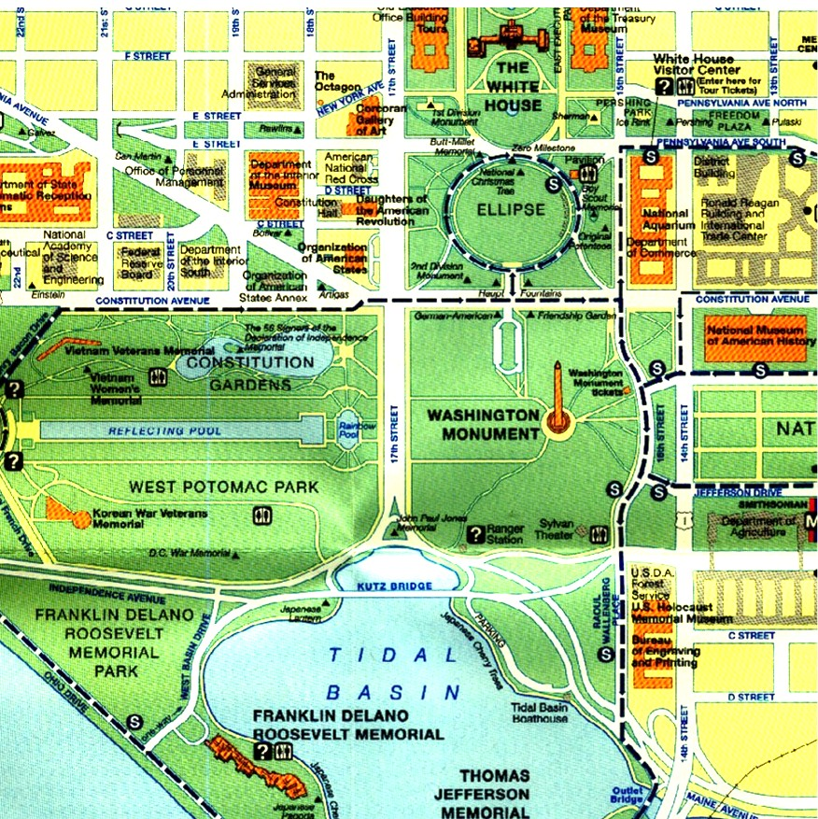

These consummate professionals, the
true Park Rangers, hope to stir visitors’ spirits, cause them to inquire further, think more deeply, and appreciate more fully these sites which we are bound to preserve. This type of employee earns more than a paycheck.

Hopefully you have brought passion and dedication with you, for without those traits it will be difficult to become a “successful Park Ranger” on the National Mall. If you bring those things, we can equip you with the information you need to excel.

To that end, this guidebook provides you with relevant, accurate information in a single source. After consulting this reference, you will be able to prepare compelling, factually-based interpretive programs for each of our memorials. The site-specific chapters provide details on the history, art, significance, and architecture of our cultural sites.

The trick is not in simply learning the material---the magic lies in delivering important messages to our visitors. To help you understand our special form of communication, this manual describes theories, applications, and the science (some would say art) of interpretation.

Don’t consider this book the “end all, be all” of your introduction to the National Mall. You will learn more from doing
than reading. At some point during your orientation you will receive training that goes into greater detail than this guidebook. Consequently, don’t expect this to be a scholarly work, footnoted ad infinitum.

On the topic of scholars, remember that our sites commemorate events or people of historic scale, but we do not expect you to be historians. Although it may be a noble aspiration, remember, we are not doctoral candidates at Princeton who must speak in tongues to communicate with fellow academics. We are public servants who deal with common, everyday visitors. Don’t read that as “common, ignorant, lowly visitors”. We are interpreters who must speak in understandable and interesting terms.

Some would argue that this is a call to “dumb down” our interpretation to make it understandable to the masses. It is perhaps more positive if we see ourselves as translators: we must try to help our visitors understand very important messages. We cannot do that if we use NPS jargon, complex labels, and incomprehensible words. We must speak their language if we expect them to understand and care about our sites and our agency’s mission.

Beyond the details that introduce you to specific sites, this guidebook will acquaint you with the park and introduce you to the important duties you'll perform in this complex, fast-paced, highly visited park. This book outlines some of the basic operating procedures and directives which Rangers must know and follow.

Just as we are not historians, though, remember that we are not law enforcement rangers either. As one Supervisory Ranger recently reminded us, we are not here to quote endless sections of the Code of Federal Regulations. We must endeavor to educate visitors about park rules in a way that encourages them to return to our parks and support us in our preservation mission.

Whether your interests are history, politics, sociology, psychology, natural sciences, education, or art, you will find something at our Mall that captures your curiosity. This park challenges Rangers with numerous duties, but it also offers many opportunities for them to grow and develop. This guidebook briefly discusses some of those special programs or collateral positions.

Again, glad to have you with us. You will no doubt bring special skills and passions to this job that will improve our organization. I encourage you to have fun and enjoy this wonderful place.

But don’t lose sight that you are in a “customer service” profession. Your job calls for you to protect the cultural and historic sites with which we have been entrusted while providing a safe and meaningful experience for each and every visitor.

Good Luck!

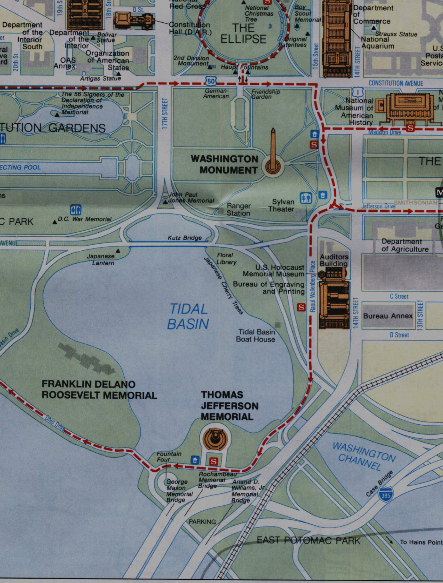

Your First Few Days.



Inprocessing and Orientation. We anticipate that the first two weeks of your job will be somewhat overwhelming as we introduce you to scores of new people, places, and procedures. The idea is to give you enough information that you begin to feel comfortable---not overwhelmed. There are clear priorities in the midst of the chaos:

- Find a place to live and get settled. Hopefully we have given you some ideas on where to look for housing, but if you are experiencing problems in finding a place or arranging for receipt of household goods, talk to a Supervisor.

- Complete Administrative Paperwork. One of our staff members will transport you to our park offices at 900 Ohio Drive. That is our park headquarters building: home to our Superintendent, Visitor Services staff, and administrative technicians. You will fill out some forms on the spot and you will be given others to take away and complete by strict deadlines: two of the more important forms are the Direct Deposit form which you will take to a bank of your choosing, and secondly, the enrollment package you will use to select a health care provider.

Once you have completed your administrative inprocessing at the park headquarters building, you will need to see our own administrative technician at Survey Lodge to fill out other paperwork such as personal data sheets and forms to obtain a parking pass, nametags, DOI identification badge, uniforms, etc. If you have been assigned a Supervisory Ranger by this time, you should expect to have a counseling session with them as well. When you meet with your Supervisor, ask about your NPS badges, keys, and lieu day (weekend) assignment.

Uniforms. While assigned to the National Mall, you will be required to wear the Class A uniform. If you are not sure what this includes and excludes, speak with your Supervisor or other Rangers. If you have not received your uniform allowance, instructions for ordering your uniform on-line, or your uniform account password, see your Supervisor immediately--it often takes weeks to receive your uniform items from our supplier! Other Rangers may be willing to loan surplus uniform items. If you don't have a uniform, most Supervisors will direct you to wear a yellow NPS Volunteer ballcap along with civilian attire while you wait for your uniform.

Tour. At some point during your first week, one of our more experienced Rangers will provide you with an orientation tour of the National Mall and its environs. If we forget to schedule you for this tour, make sure you request it!

This can be one of the most important tours you'll ever take because it shows how our park fits into the city and the Nation's Capital. Visitors will expect you to know much about space, distances, and local attractions. Do yourself a favor and get a feel for the city early on in your stay. Try and walk where tourists walk, drive where they drive, eat where they may eat.
Training. If you are coming onboard with several other new employees, you may receive a formal class. Training topics range from interpretation to the Code of Federal Regulations.

Shadowing. Normally, you will receive two weeks of "On the Job Training". Under this program, Supervisors will assign new Rangers to shadow or accompany seasoned Rangers throughout the course of a normal duty day. Depending upon staffing levels, Supervisors may assign you to a specific site or memorial for several days in a row, or you may accompany a specific Ranger throughout his or her week. The goal of this training is to familiarize you with the peculiarities of working at each memorial. Ask questions—Rangers will be glad to tell you about their experiences, and we have Rangers who have been here since the 1970s!

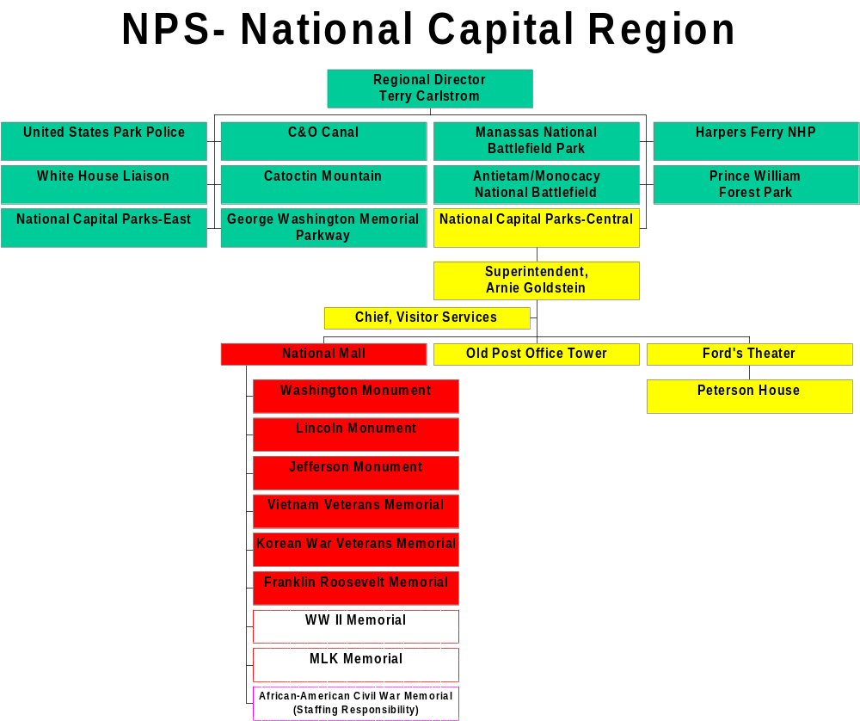
Where we fit into the big picture. We work for the Mall Operations Site Manager, who in turn works for the Chief of Visitor Services, National Capital Parks-Central. Therefore, our “park” is technically “National Capital Parks-Central”, under the leadership of Superintendent Arnie Goldstein.

Notes:

-Both the World War II and Martin Luther King, Jr. Memorials are planned but not yet built.

-In the past, Mall Rangers have staffed the African-American Civil War Memorial, but is not technically under the administrative control of the NPS.
TELEPHONE LIST

US PARK POLICE:
EMERGENCY: 202-619-7300
Non-Emergency: 202-619-7310
Lost and Found 202-426-6849

NATIONAL CAPITAL PARKS-CENTRAL

Mailing address:
900 Ohio Drive, S.W.
Washington, D.C. 20024

Public Number to Superintendent’s Office 202-485-9880

Superintendent Arnold Goldstein 202-485-9875
Secretary Donna Wion 202-485-9875
Deputy Superintendent Vikki Mcgraw Keys 202-485-9876
Chief, Div. of Administration Consuella Joy 202-485-9869
Chief, Div. of Park Programs Richard Merryman 202-619-7178
Chief, Div. of Resource Mgmt Stephen Lorenzetti 202-485-9680
Chief, Div. of Visitor Services Vacant 202-485-9683
Interpretive Specialist Robert Fudge 202-485-9684
Special Asst, Land Use & Partnerships Lisa Mendelson 202-485-9870
Management & Program Analyst Sharon Wheat-Laster 202-485-0015
Safety Manager Vacant 202-485-9698

Human Resources:
Chief, Div. Of Administration Consuella Joy 202-485-9869

Personnel Assistant: Jeanette Brown 202-485-9867
(Vacancy announcements, qualification determinations, staffing issues)

Personnel Assistant Cynthia Gibson-Brockett 202-485-0243
(Pay and leave, service credit, LES problems, address and tax changes, benefits)

Personnel Officer: Cynthia Knox 202-426-9300
(Vacancy announcements, qualification determinations, staffing issues)

Personnel Staff Assistant: Mary Luppino 202-426-9299
(Disciplinary and adverse actions, leave issues, leave without pay)

Employee Relations Specialist: Vacant 202-485-9861

Personnel Receptionist: Marie Rollinson 202-485-9880

Personnel Assistant: Kim Ross 202-485-9872
(Vacancy Announcements, qualification determinations, staffing issues)

Personnel Assistant: Lavanna Stevenson 202-485-9871
(Vacancy Announcements, qualification determinations, staffing issues)
Maintenance Section:
Associate Superintendent, Maintenance William I. Newman 202-485-9880
Deputy Chief of Maintenance Sean Kennealy 202-485-9880
Chief, Br. of Grounds And Trees Milton Boston 202-4264765
Chief, Br. of Facilities Maintenance Samuel Nichols 202-426-6860
Chief, Br. of Roads & Trails Harry Olinger 202-426-7730
Chief, Br. of Transportation Carl Stovall 202-426-7730
Carpenter Shop Willie Delk 202-426-6866
Electric Shop Raymond Hall 202-426-6846
Mason Shop Michael Proctor 202-426-6864
Paint And Sign Shop Lowell Lamont 202-426-6873
Plumbing Shop Stephen Hoover 202-426-6883
Metal Craft Shop William Gibson 202-426-6870
Steam Cleaning Shop Kenneth Parker 202-426-6875
Special Events (flags) Floyd Smith 202-426-6790
Receiving Department Robert Herald 202-426-0985
Brentwood Storehouse Joan Proctor 202-426-6900
Auto Mechanic General Foreman Vacant 202-426-6888
Truckshop Frank Gerald 202-426-6890
USPP Garage George Harley 202-426-6869

Sites:
Ford's Theatre Suzanne Kelley 202-426-6924
Peterson House 202-426-6830

Old Post Office Tower Stanley Cofield 202-606-8691

National Mall:
Survey Lodge Lance K. Hatten 202-426-6924
Survey Fax 202-426-1844
Jefferson Memorial 202-426-6822
Korean War Veterans Memorial 202-632-1001
Lincoln Memorial 202-426-6896
Vietnam Veterans Memorial 202-634-1568
Washington Monument 202-426-6839

Non-NPS Numbers:

American Battle Monuments Commission (KWVM, WWII) 703-696-6900
DC Animal Control 202-576-6665
Ticketmasters DC 202-432-7328
Tourmobile 202-554-7950
VVMF (Donations, Directory Books) 202-393-0090
WWII Memorial Commission 703-696-6650

Parks & History Bookstore, Jefferson Memorial 202-426-2177
Parks & History Bookstore, Lincoln Memorial 202-653-9088
Parks & History Bookstore, FDR Memorial 202-472-3083

Radio Call Sign Sheet

